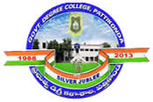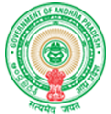**Government Degree College**

**ACCREDITED BY NAAC WITH ‘B’ GRADE** **Pattikonda,Kurnool (Dt),A.P.518380.**

**Dr R Madhuri,**

**Principal ,**

**Strategy Development and Deployment**

**The institutional Strategic/ perspective plan is effectively deployed**

**Response:**

**Every year perspective plans are evolved and deployed through action plans, academic and administrative activities and time to time review of respective outcomes to ensure the attainment of strategic plan. At every level there will be an effective monitoring and documentation. The perspective plan for development comprises the following:**

* **To achieve excellence in academics, teaching and learning**
* **To foster/facilitate a student centric development**
* **To provide better infrastructural facilities**
* **To enhance the social relevance of the institution**
* **To identify sources and mobilize funds**
* **To complete the automation process and achieving a paperless office administration.**
* **To empower the students through information, guidance, training and support services.**
* **To enhance the students’ domain knowledge and soft skills through Jawahar Knowledge Centre (JKC).**

**Successfully implemented activity: Implementation of new courses:**

**The college implemented new courses like B.SC Aqua culture technology, B.SC Organic Forming, B.A Computers, B.SC (BCCs) in the year 2021-22. Ours is the only Non-autonomous College in the University our college always tries to introduce new courses which enhances knowledge and employability skills which is part of our Vision and Mission.**

